**Part 1:**

I tried to work on the regular expression exercises as I found it important when we have it in the class but reading it from the book was a struggle for me. The two links for the books on Gutenberg does not work. Although I managed to get the books, I got lost on how to perform the exercise on them. The first part in this chapter was very confusing to me. Also, the exercise [9.4] Finding the Percentage of Quoted Text” did not work with Jupitar.

**Part 2:**

I want to discuss a scholarly work done with python and Natural Language Toolkit (NLTK). The project use python to analyze large data set of literature, it counts and analyze in color words. The link to the project is: <https://afternoon-taiga-69837.herokuapp.com/>

It simply start by selecting the author name, then it helps to visualize the authors top words, showing his articles and count the words in every novel, and visualize the full list in color pattern. As shown below:

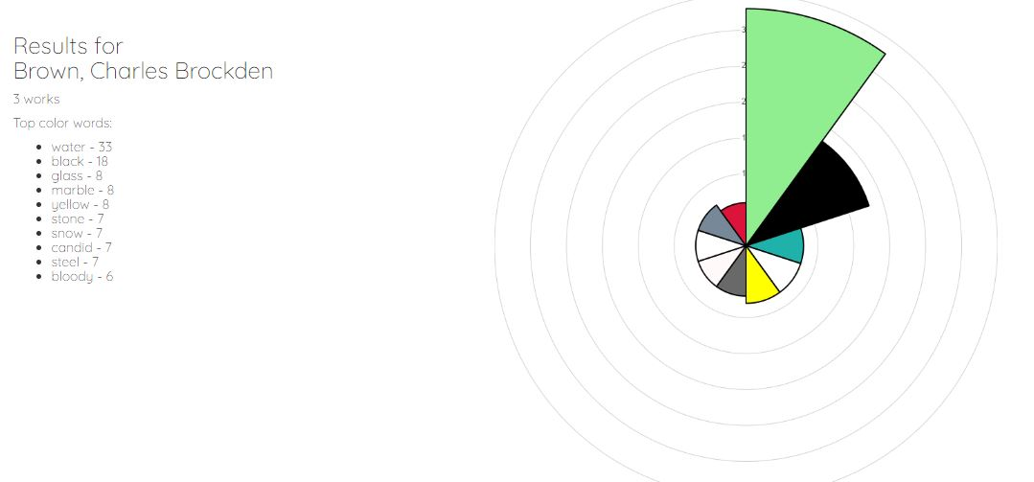

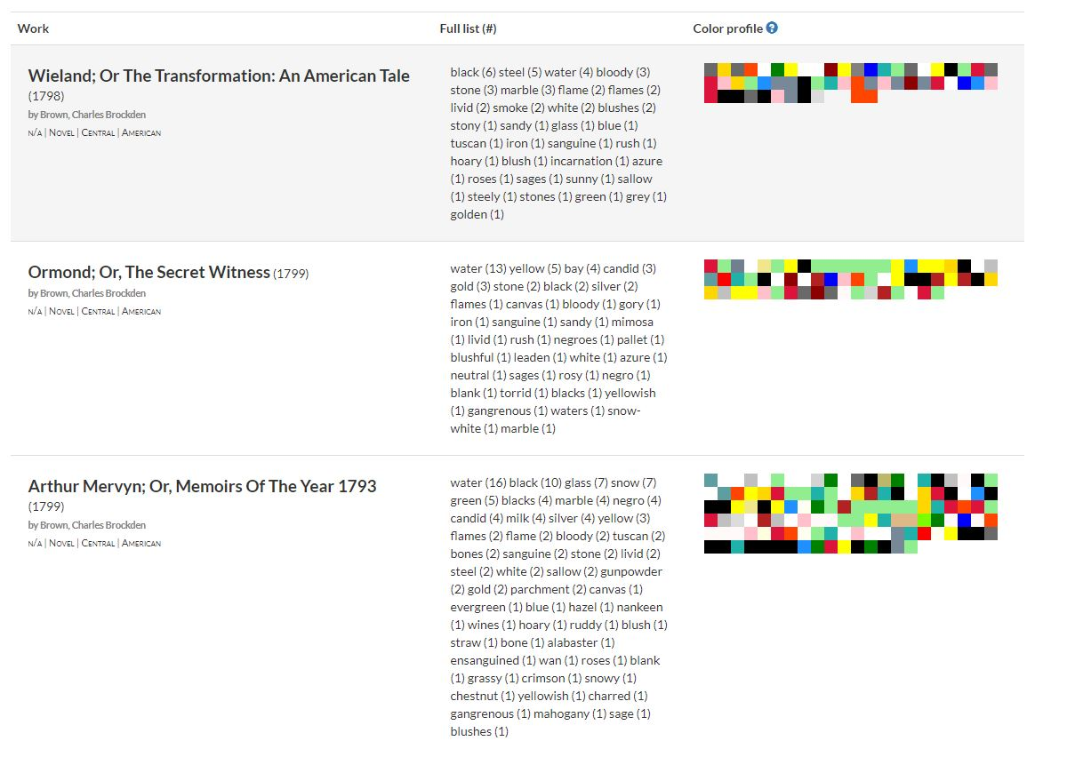

Using Jupiter Notebook and the gothic era, the developer started to find a way to define color words because “The challenge here was that both the vocabulary used to describe color and the actual coloring of objects themselves were different in the gothic era than in present day”. To solve this problem they based their analysis on the Oxford English Dictionary’s Historical Thesaurus adding some html color names and grouped them in original data set.

I feel this project is as useful as it explains easily how to count words and visualize them in color pattern.

**Part 3:**

I am struggling to understand the connection of all the small aspects we are taking. I feel the importance of them but I don’t know how to combine them in a project or to use them in my project with all the struggles I find when I read the book and it is really frustrating.